HND Web Development

Developing Mobile Web Applications an Introduction

HF4Y 34

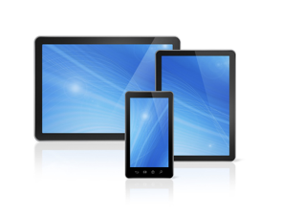

LO1 Report: Compare the features of mobile devices and industry structure that can affect the production of mobile web based applications.

|  |  |
| --- | --- |
| **Student Name:** |  |
| **Class:** |  |
| **Tutor:** |  |
| **Submission:** |  |

Contents

Report Overview 3

Section 1 - Describe the current mobile industry structure including device manufacturers and network or service providers 4

Section 2 - Compare a range of current mobile devices including differences, popularity and uses 6

Section 3 - Compare the popular mobile device operating systems and their restraints 7

Section 4 - Explain the design principles applicable to the mobile environment and the constraints set by the operating system 8

Section 5 - Compare mobile websites, native apps and hybrid apps including architecture, strengths and weaknesses 9

Bibliography 10

Report Overview

For this LO1 report document you will be required to research the following areas before addressing the main sections contained within this document.

* Current mobile industry structure
* Mobile device product range
* Mobile device operating systems
* Design principles applicable to the mobile environment
* Mobile experiences — mobile websites, native apps and hybrid apps

Section 1 - Describe the current mobile industry structure including device manufacturers and network or service providers

The current mobile industry is dominated by two major companies, Apple and Samsung with Apple Holding a >50% market share on the mobile industry whereas Samsung hold a >30% market share. As shown in the graph below apples dominance in this market is clear to see, Whereas Samsung has had a steady rate of growth but have not reached the same levels as Apple.

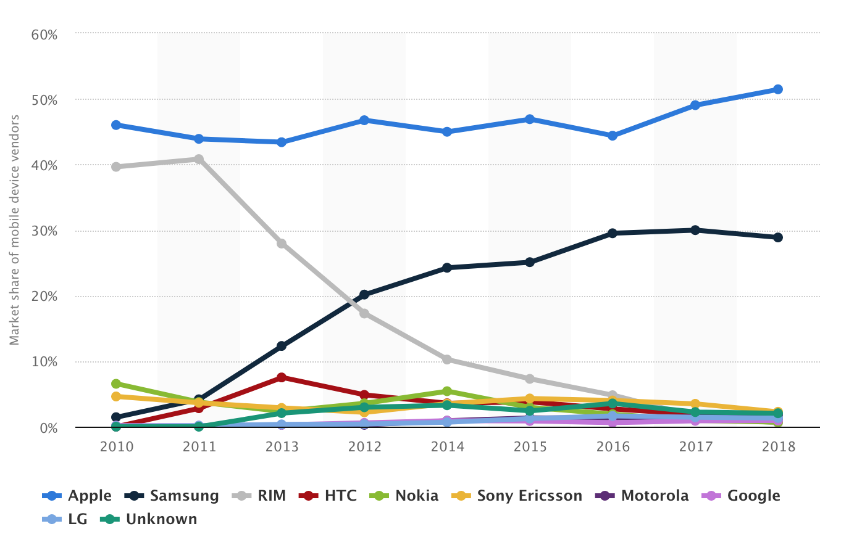

Apple have dominance in the market because of their wide range of products including the iPhone (At Least One New Model Every Year) And The iPad. Additionally, they were first to create a major touchscreen smartphone with the original iPhone back in 2007, this contributes to their control of the market. I believe that apple maintain their grasp of the market because they have established themselves as a household brand and their user-friendly design principles. Apple also maintain a regularly updated operating system.

Samsung has a major portion of the market share, this is due to them using an less restrictive operating system. this allows for the users to modify their system to their specific requirements and taste. Samsung have a variety of products similar to Apple, these include the Galaxy S Phone (Which have a new model every year), Galaxy Tab Their Tablet Model and their larger Note Phone. Samsung appeals to the more tech oriented consumer, this is due to them usually being the first in the market to use the latest technology (Wireless Charging, Fast Charging, Virtual Reality Capabilities etc.).

The mobile networks market is topped by EE (+BT Mobile) with O2 being a close second. EE maintains a 28% market share whereas O2 holds 26%.

Section 2 - Compare a range of current mobile devices including differences, popularity and uses

There are a variety of mobile devices on the market currently the most popular and current are; Apple iPhone XS, Samsung Galaxy S9, Huawei Mate 20 Pro.

The Apple iPhone XS was released in Q4 2018. The main features of this new model is its flagship new a12 bionic chip, the most powerful CPU in a phone to date. This chip allows the iPhone to complete very demanding tasks such as Augmented Reality. The iPhone Features a 5.8-inch super retina OLED display with a 458 PPI pixel density.The iPhone XSMAX has a Dual 12-megapixel rear camera with a 7megapixel face-id camera on the front. The iPhone XSMAX retails for £1099 (Apple.com)

The Samsung galaxy s9 phone was released in Q1 2018. The s9 has no major new features just improvements on existing features e.g. the camera has been updated with a dual aperture lens. The galaxy s9 features a 5.8 inch OLED display with a 570 PPI pixel density also a 12 megapixel camera,8-core 2.8 GHz Processor. The Samsung Galaxy S9+ retails for £869 (Samsung.com)

The Huawei Mate 20 Pro was released in Q4 2018. The screen is a 6.39 inch touchscreen display with a 538 PPI Pixel Density. The Huawei Mate 20 Pro has a octa-core 2.6 GHz processor and 6GB of RAM as standard, the phone starts at 128 GBs of storage but can be bumped up to 256GB. The Huawei mate 20 pro also features a 40-megapixel rear camera and a 24-megapixel front camera. The Huawei Mate 20 Pro Retails for £650 (O2.co.uk)

In conclusion when it comes to value for money the Huawei Mate 20 Pro is the clear winner, boasting similar specs to its competition at half the price, in terms of looks in my opinion it has to be the iPhone XSMAX, the sleek and minimalistic look of the phone just ticks all of the right boxes, for me anyway.

Section 3 - Compare the popular mobile device operating systems and their restraints

When comparing the operating systems of the modern smartphones there are really only 2 contenders; Apples iOS and Googles Android. These two are very different things as Apple iOS is a UNIX based operating system whereas Android is a Linux based operating system.

There are other big differences between them also;

|  |  |  |
| --- | --- | --- |
| FEATURES | APPLE IOS | GOOGLE ANDROID |
| OPEN SOURCE | NO | YES |
| OS FAMILY | UNIX | LINUX |
| RELEASE DATE | 29/07/07 | 23/09/08 |
| DEVELOPER | APPLE INC | GOOGLE INC |
| CUSTOMIZABILTY | LIMITED | MOST THINGS |
| AVAILABLE DEVICES | ONLY APPLE DEVICES | MOST DEVICES |
| SECURITY | MOST USER DON’T DOWNLOAD FROM ANYWHERE OTHER THAN THE APP STORE,THEREFORE DON’T ENCOUNTER ANY MALWAR | AS ANDROID IS OPEN SOURCE MANY MANUFACTURERS WILL BE BEHIND OF ANY GOOGLE DEVICES WHEN IT COMES TO UPDATES TO SECURITY |

Section 4 - Explain the design principles applicable to the mobile environment and the constraints set by the operating system

When designing for the mobile environment there are some key principals to take in mind, you need to remember that phones are generally smaller than laptops and desktops therefore you need to design accordingly, the last thing you want is a horizontal scrollbar while trying to use a website on your phone. Once you’ve correctly sized your content to the device size you need to have simple navigation, this is another size issue because you can imagine that using traditional navigation on a mobile touchscreen would be almost impossible, you tend to see in most modern mobile websites/apps a ‘hamburger button’ which usually toggles a section of the page that contains the navigation, this section tends to take up the majority of the page. When displaying content on the mobile you need to choose the most relevant/important content as there is less real-estate to use, this may come down to removing whole sections of a webpage. Mobile devices tend not to have as good of a connection as desktops and laptops when you take this into account developers should keep the amount of graphics featured in the app/website to a minimum.

Section 5 - Compare mobile websites, native apps and hybrid apps including architecture, strengths and weaknesses

When developing for the mobile environment you have 3 main options native apps, web apps and hybrid apps.  
  
Native apps are what people generally think of when people talk about apps, Native apps are apps that are developed using the programming language that is used by the device’s operating system, this means that a native app is generally developed for a specific operating system/device this also means that if you want your app on more than one platform you will have to re-code the app in its respective language thus increasing costs to produce the app. As native apps run on the mobile phones operating system it has access to all of the features of the mobile device e.g Camera, Microphone, Contacts etc.

Web apps are websites that are designed to be used on a mobile device, this means that they are programmed in the languages used to make websites e.g HTML, CSS And Java Script, this means they can be run on any mobile device that has a browser to access said web app, thus making it much cheaper and faster to create than a native app. There are some restrictions that come with using a web app; you require internet access to even use the app at all this is because you never actually download the web app you are just revisiting the same website every time you wish to use said web app this means that a web app can never be as fast as a native app, also a web app cannot use the features of a mobile device e.g Camera, Microphone etc.

Hybrid apps are a balance of the other two methods, with a hybrid app you are essentially making a native app that can be downloaded onto your phone from the app store that displays a web app, but allows the web app to also have the benefits of a native app e.g mobile features Camera, Microphone etc.

Bibliography

<https://www.statista.com/statistics/487780/market-share-of-mobile-device-vendors-uk/>

https://www.statista.com/statistics/375986/market-share-held-by-mobile-phone-operators-united-kingdom-uk/

https://www.cable.co.uk/guides/ee-mobile-vs-o2-mobile/